**Personal Blog On IBM Cloud Static Web Apps**

**Phase 3: Development Part 1**

Our project is designed to help individuals, bloggers, and content creators establish their online presence and share their thoughts, stories, and expertise with the world. By leveraging the power of IBM Cloud's Static Web Apps, you can ensure your blog is fast, secure, and easily accessible to your audience. This blog will serve as a platform for sharing personal experiences, knowledge, and insights with an online audience.

**Objectives :**

- Developing our travel blog website using HTML, CSS, and JavaScript.

- Ensuring that the website is entirely static, featuring articles, images, and content related to the travel experiences.

**HTML Structure :**

Our HTML structure typically includes the following elements:

1. <!DOCTYPE html> : The document type declaration.

2. <html> : The root element of your HTML document.

3. <head> : Contains metadata such as the page title, link to stylesheets, and other information.

- <title> : Sets the title of your webpage.

- <link> : Links to external CSS files.

4. <body> : Contains the visible content of your webpage.

- <header>: Typically contains the site's name and navigation.

- <nav> : Navigation menu.

- <main> : The main content area.

- <article> : Represents an individual blog post.

- <section> : Used to divide content into different sections.

- <aside> : Sidebar for additional information.

- <footer> : Contains footer information like copyright and contact details.

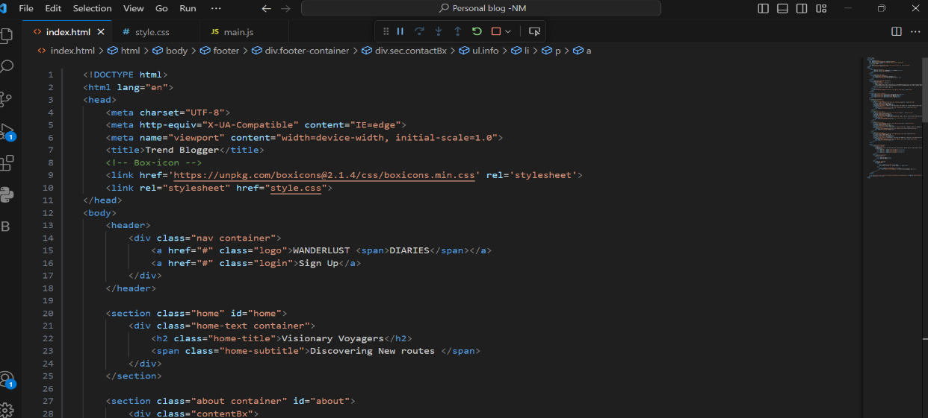

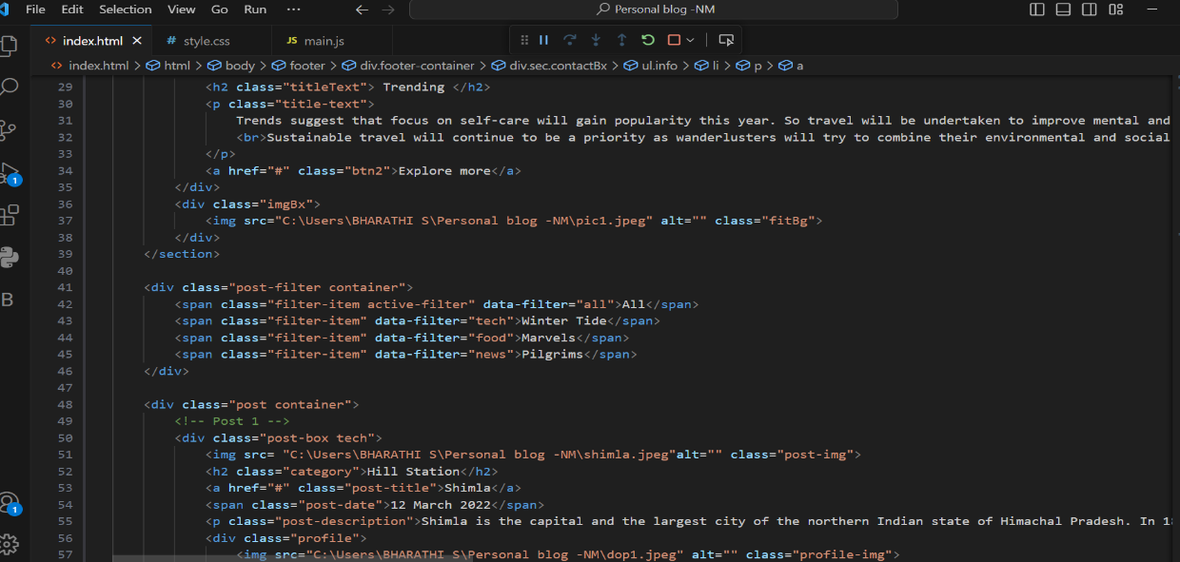

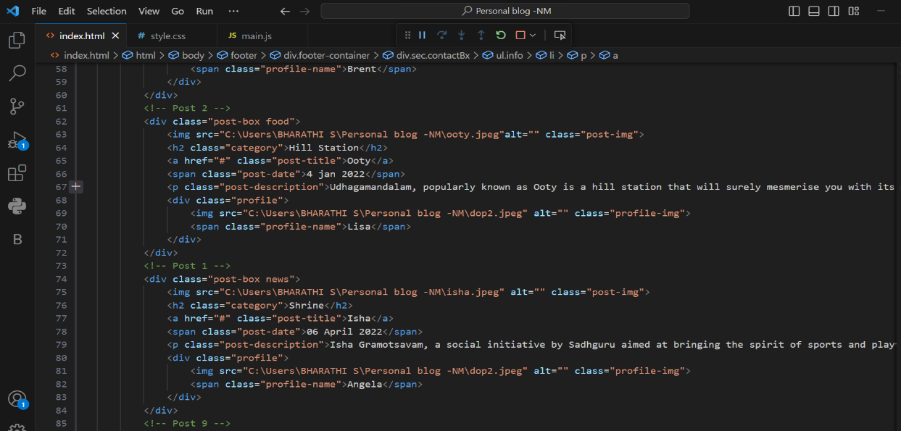

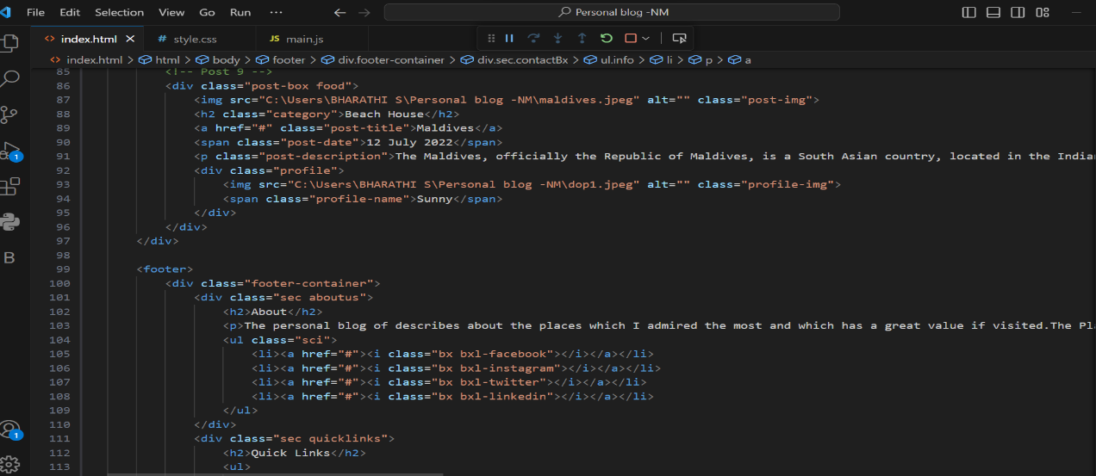

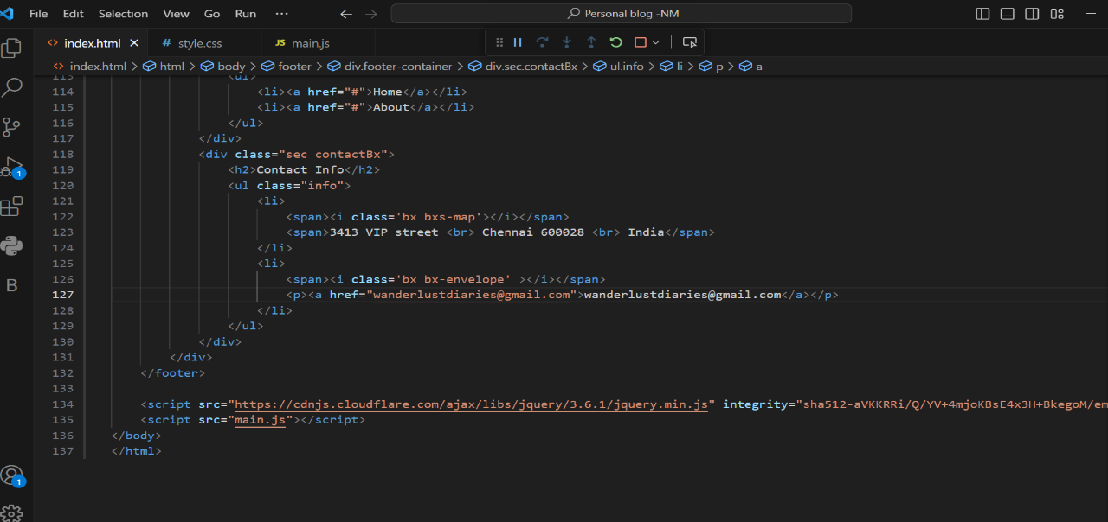

**CSS Styling :**

Used CSS to style our website. Common CSS elements and properties include:

- Selectors (e.g., body, .header,#nav)

- Properties (e.g., color, font-size, background-color)

- Box model (e.g., margin, padding, border)

- Layout (e.g., display, position, float)

- Fonts (e.g., font-family, font-size)

- Colors (e.g., background-color, color)

- Text (e.g., text-align, line-height)

- Styling links (e.g., a:link, a:hover)

- CSS Grid and Flexbox for layout design.

- Media queries for responsive design.

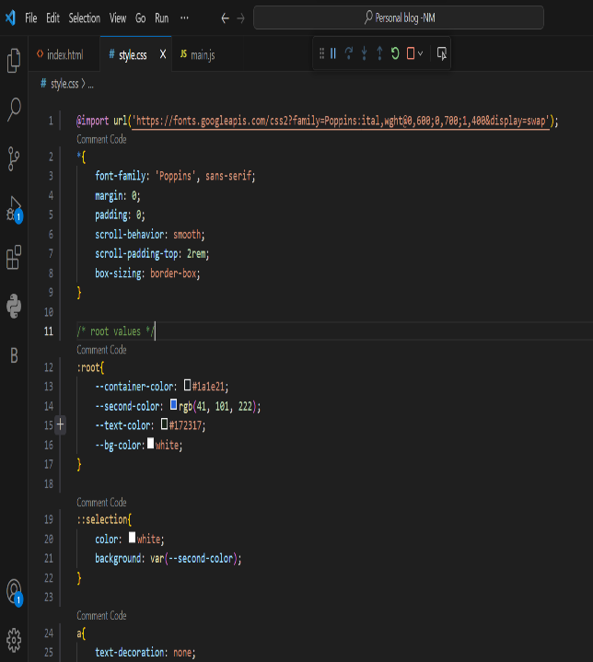 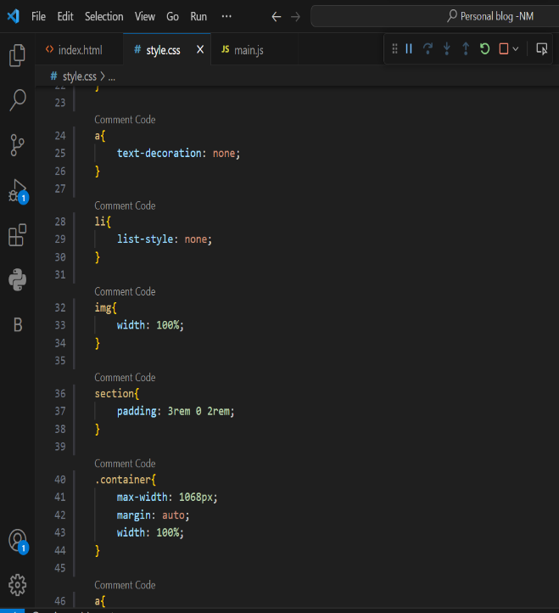

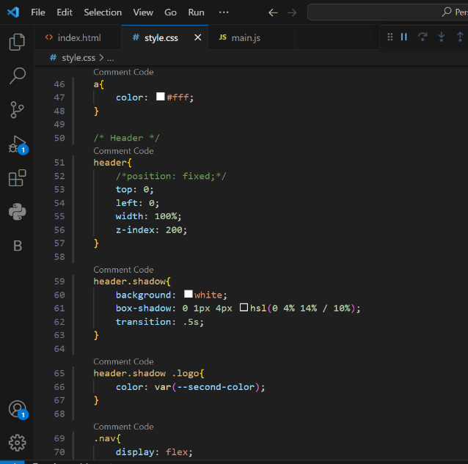 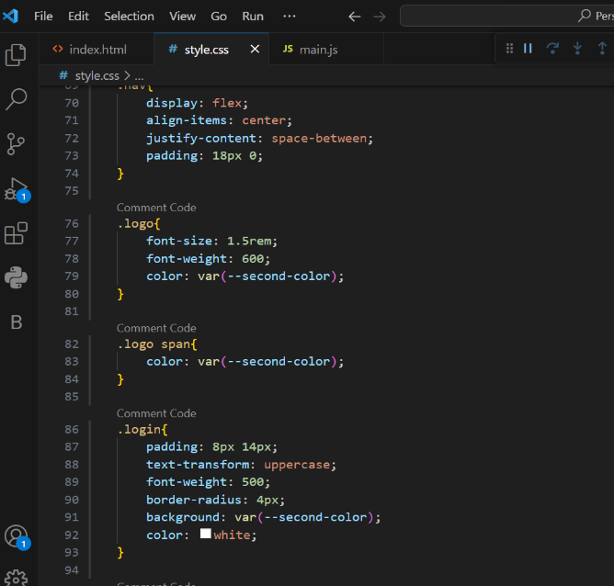

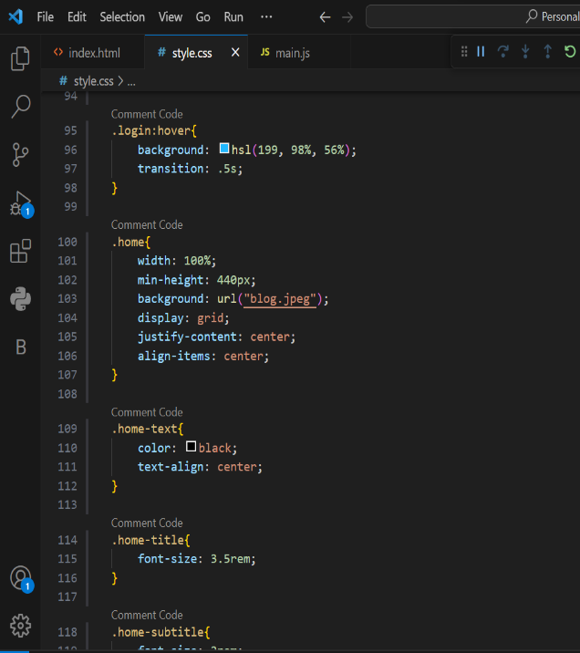 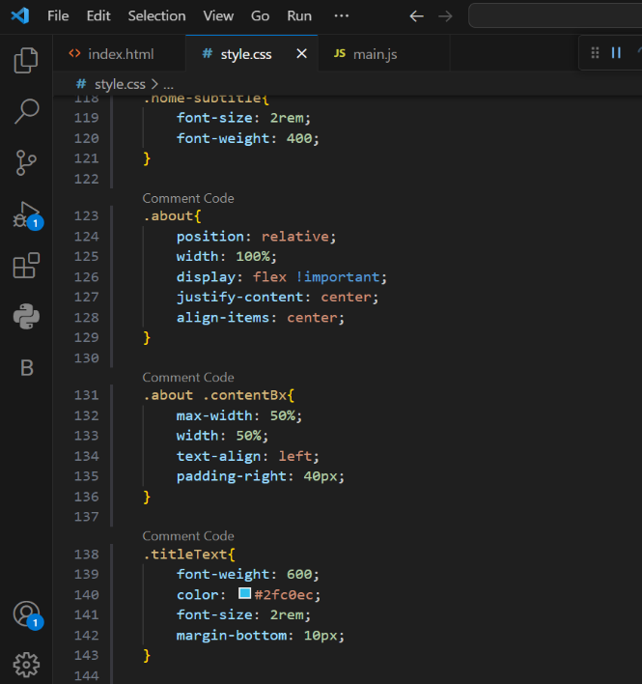

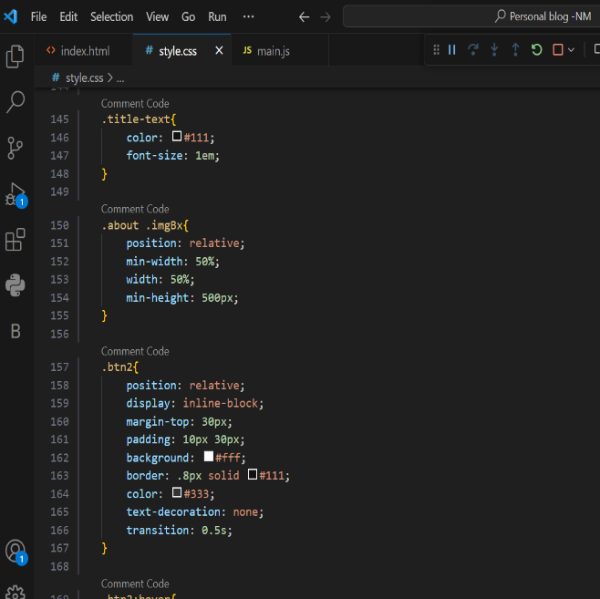 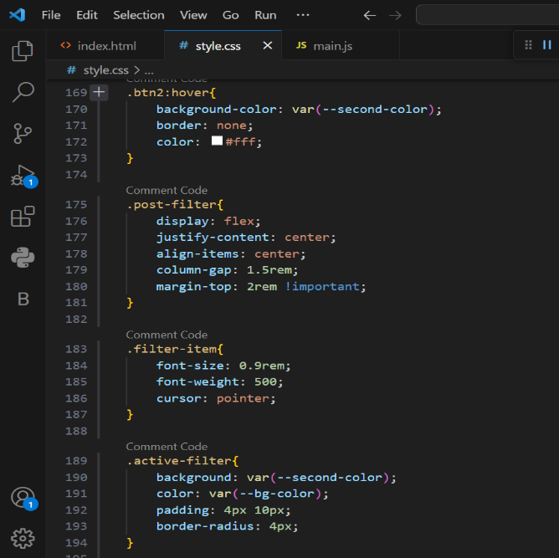

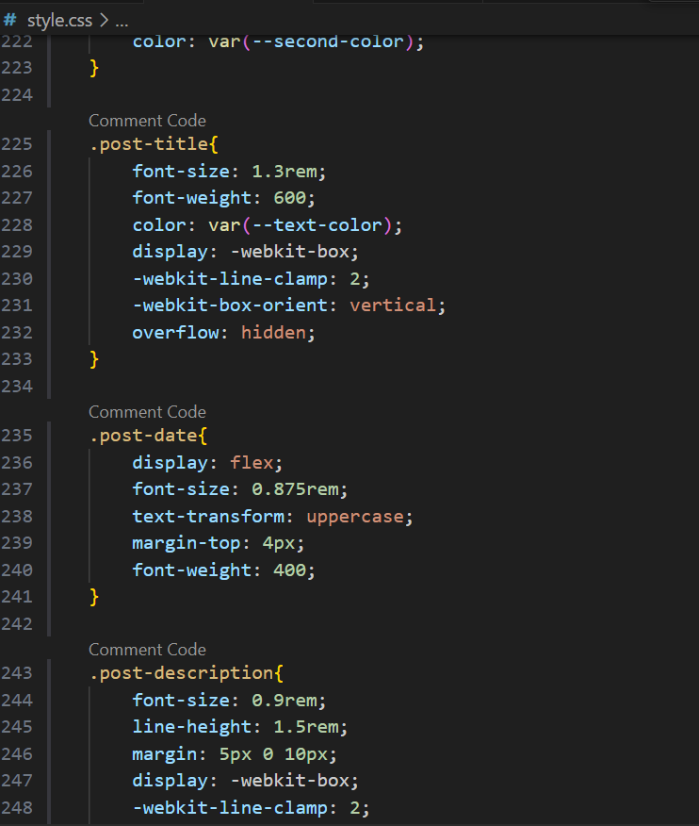 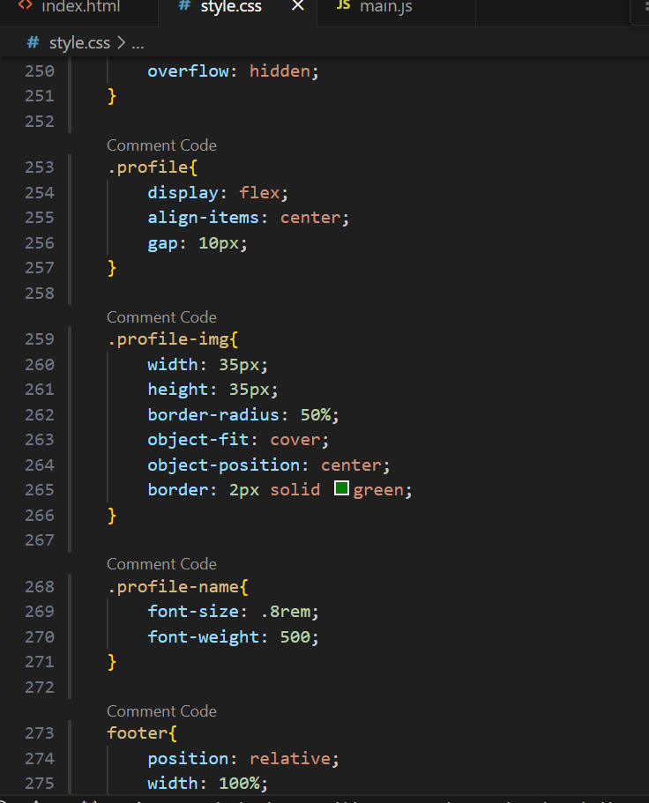

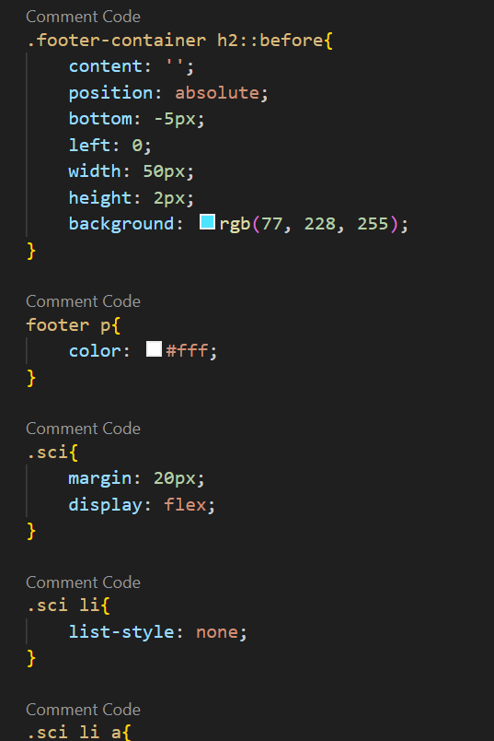 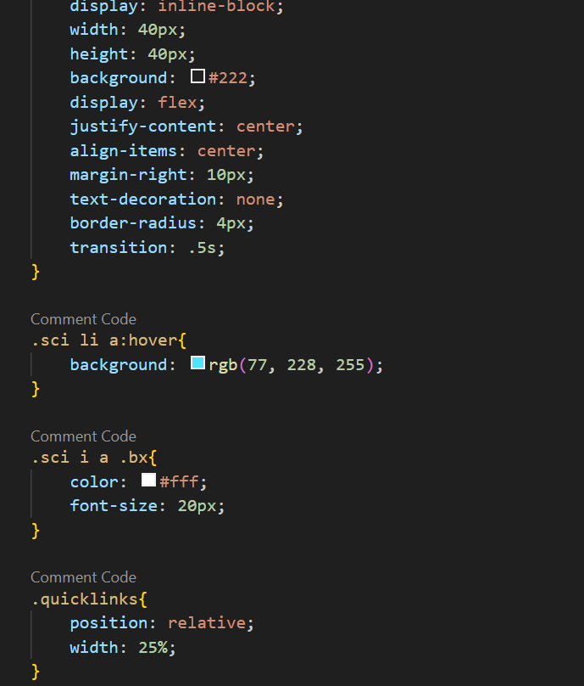

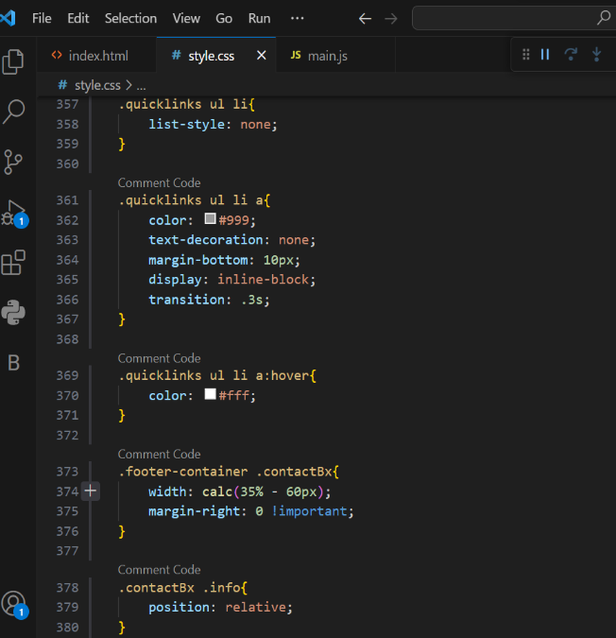 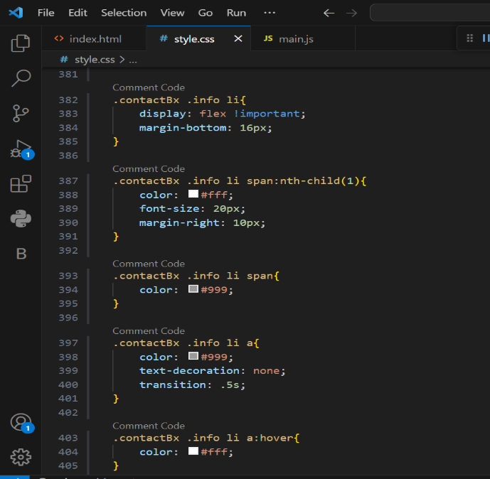

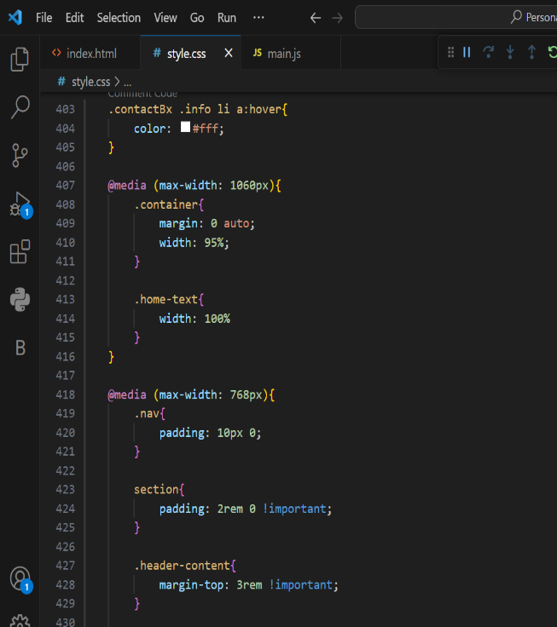 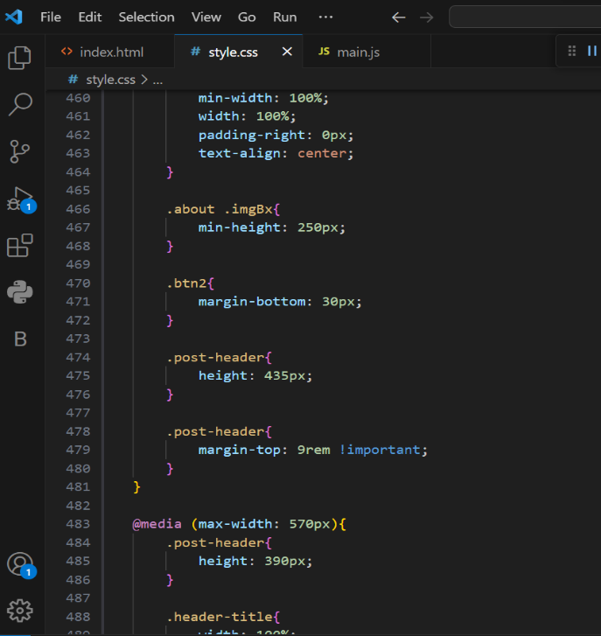

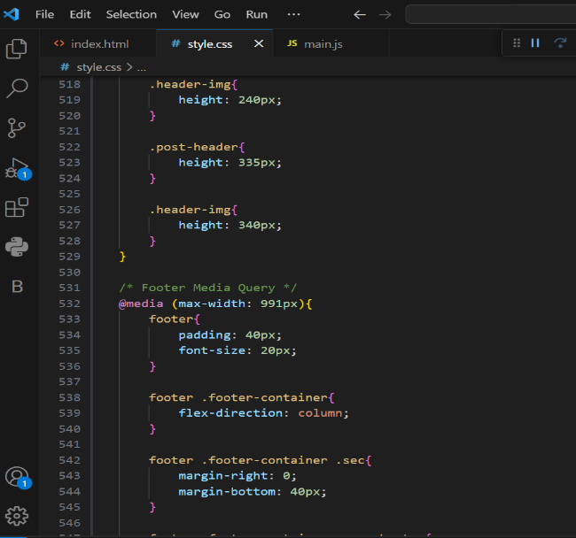 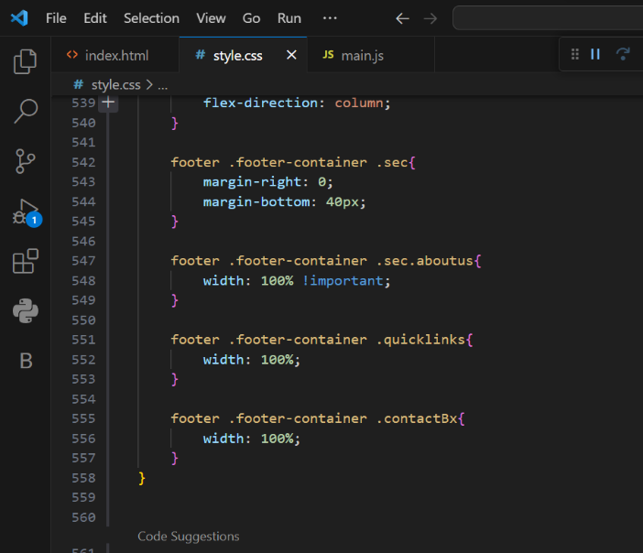

**Adding Content :**

- Create blog posts using HTML, typically within ‘<article>’ elements.

- Include headings (<h1>, <h2>, etc.) and paragraphs (<p).

- Add images using ‘<img>’ tags.

- Use lists (<ul>, <ol>) for items or articles.

- Format text using ‘<strong>’, ‘<em>’, and other inline elements.

**JavaScript Interactivity :**

Interacting with our personal blog, For that we used JavaScript tasks like:

- Implementing a comment system.

- Creating a search bar.

- Adding a light/dark mode switch.

- Animations or transitions.

- Handling forms for contact or comments.

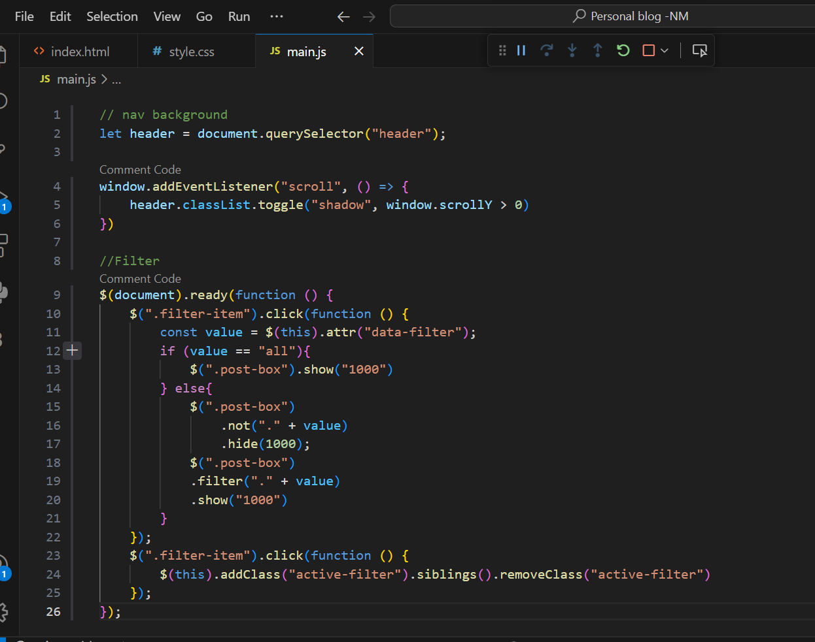

**LAYOUT**

